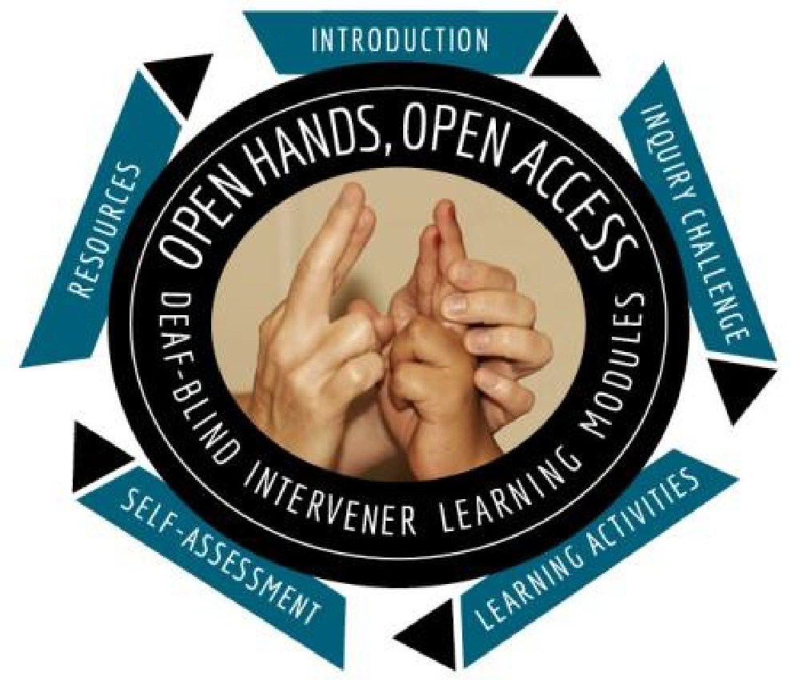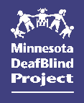

Open Hands, Open Access: DeafBlind Learning Modules

Summer 2023 Cohorts

Sponsored by the Minnesota DeafBlind Project and American Sign Language Interpreter Services (ASLIS), an Approved RID CMP Sponsor. This General Studies program is offered for 1.2 RID CEUs at the Little/Non-Content Knowledge Level.

Begins June 20, 2023 - Ends August 1, 2023 - Online registration deadline: June 15, 2023

Fee: FREE to participants in the previous teacher, educational interpreter, and intervener OHOA
cohorts.

Target Audience: Teachers/licensed professionals, educational interpreters, and interveners serving Minnesota children and youth who are deafblind and who have participated in a previous OHOA cohort.

Register Online:

Teachers register here: Teacher OHOA Modules - Summer Cohort
Educational Interpreters register here: Interpreter OHOA Modules - Summer Cohort
Interveners register here: Intervener OHOA Modules - Summer Cohort Registration and Program Questions:
Ann Mayes 612-638-1527 | Ann.Mayes@metroecsu.org

You will receive an immediate confirmation at the email address that is submitted in our registration system. If a confirmation does not arrive, contact Ann Mayes to confirm your registration.

Training Description:

The Open Hands Open Access (OHOA) DeafBlind Learning Modules are a national resource designed to increase awareness, knowledge, and skills related to intervention for students who are deafblind and are being served in educational settings (ages 3 – 21).

Teachers and Interpreter Modules:
Module 21: Sexuality
Module 23: Behavioral Environments & Supports

Intervener Modules:
Module 16: Self-Determination Module 17: Social Skills

The training includes:

- Facilitated module format with engaging case studies, videos, slideshows, short readings, interactive group discussions and more.

- Learning from experts, teachers, interveners, individuals with deafblindness, and families.

- Distance coaching, course CEUs.

- Only 1-2 hours per week are needed to complete the modules. Both modules will be open at the same time to allow participants flexibility to complete them between June 20 and August 1, 2023. The deadline for both modules is firm.

- Guided coursework using two (2) online modules of the training series. These specific modules are only offered during our special summer cohorts.

Facilitator Information:

Carolyn Monaco has worked in the field of deafblindness for over 40 years. Her experience includes intervening, consulting, training, and teaching in the Intervenor Program at George Brown College in Toronto, Canada. Carolyn has also been one of the key presenters in MN DeafBlind Project’s intervener weekend training series for many years. Her passion is assisting others to gain the skills and knowledge they need to improve the lives of those with deafblindness. She received an Anne Sullivan Macy Medal in 2018 for her outstanding work. When she isn’t working, Carolyn enjoys traveling, gardening, and decorating her home.

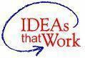
Funding for this initiative is made possible with a grant from the MN Department of Education. The source of the funds is federal award Special Education – Programs to States, CFDA 84.027A and Special Education – Technical Assistance and
Dissemination to Improve Services and Results for Children with Disabilities, CFDA 84.326T. The activity does not necessarily represent the policy of the federal Department of Education or the state Department of Education and you should not assume endorsement by the federal or state government.
